**Microsoft Project 2016: Tutorial 3**

**Task Dependencies**

**1. Adding task dependencies**

Open the “SimpleSoftwareProject” project. It should contain a task list, where each task has a Name and a Duration. We will now link tasks based on their dependencies. The dependencies for the “SimpleSoftwareProject” tasks are given below:

|  |  |  |  |
| --- | --- | --- | --- |
| **Task ID** | **Task name** | **Duration** | **Predecessor** |
| 1 | Design | 3 days |  |
| 2 | Design admin software | 3 days |  |
| 3 | Design user software | 2 days |  |
| 4 | MS1 | 0 days | 1 |
| 5 | Implement | 7 days |  |
| 6 | Implement admin software | 3 days | 2 |
| 7 | Implement user software | 7 days | 3 |
| 8 | MS2 | 0 days | 5 |
| 9 | Test | 2 days |  |
| 10 | Test admin software | 1 days | 6 |
| 11 | Test user software | 2 days | 7 |
| 12 | MS3 | 0 days | 9 |
| 13 | Deploy system | 2 days | 10, 11 |

MS Project allows for various types of task dependencies. In this tutorial, we are concerned with the most commonly occurring – the Finish to Start dependency, which occurs when a task must finish before a related task can start. (This is the type of dependency that we have been using in the critical path analysis examples studied in previous weeks). For example, from the table above we can see that Task 2 (Design admin software) must be completed before Task 6 (Implement admin software) can begin (which sort of makes sense). Similarly, both Task 10 and Task 11 (Test admin software and Test user software) must be completed before Task 13 (Deploy system) is started.

These dependencies are modelled in MS Project by linking tasks. This can be done in several ways. One way to do this is to: select the two tasks that you want to link (use CTRL/left-click to select multiple tasks), then switch to Task tab and from the Schedule group select Link the Selected Tasks button.

Use this method to insert the following links:

* Task 2, Task 6
* Task 3, Task 7
* Task 6, Task 10
* Task 7, Task 11
* Task 10, Task 13
* Task 11, Task 13

We will also include links between Milestones and Summary tasks:

* Task 1, Task 4
* Task 5, Task 8
* Task 9, Task 12

Your project Gantt chart should now look like:

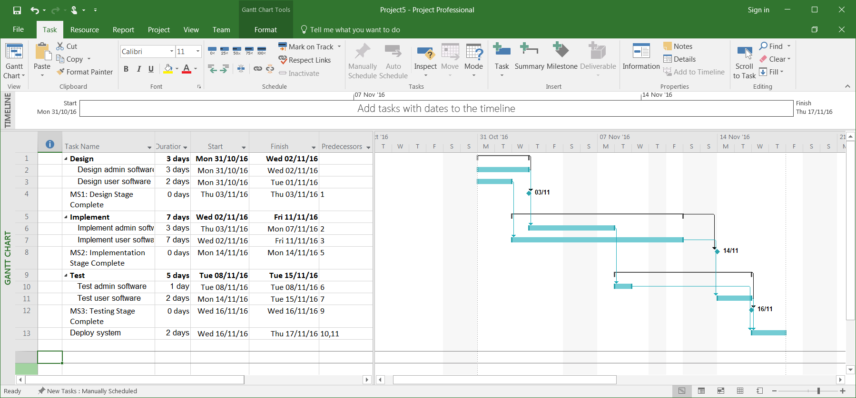

Links between tasks are shown by thin blue connecting arrows. The start dates of tasks that have predecessors have automatically been updated to reflect dependencies.

Links can also be inserted via the Predecessors tab found in the Task information dialog box (double-click a Task to open the dialog box) – experiment with this if you have time. Alternatively, you can also simply type the appropriate task ids into the Predecessors column of a task.

**2. Respecting links**

By default, a MS Project project will operate in Manually Schedule mode. This gives you (the user) control over where tasks appear in a project schedule. However, care must be taken in some instances. For example, consider a situation in the “SimpleSoftwareProject” project where the estimated duration of Task 2 (Design admin software) is increased from 3 days to 5 days. This can be incorporated into the plan by editing the Duration value of Task 2, which will give you:

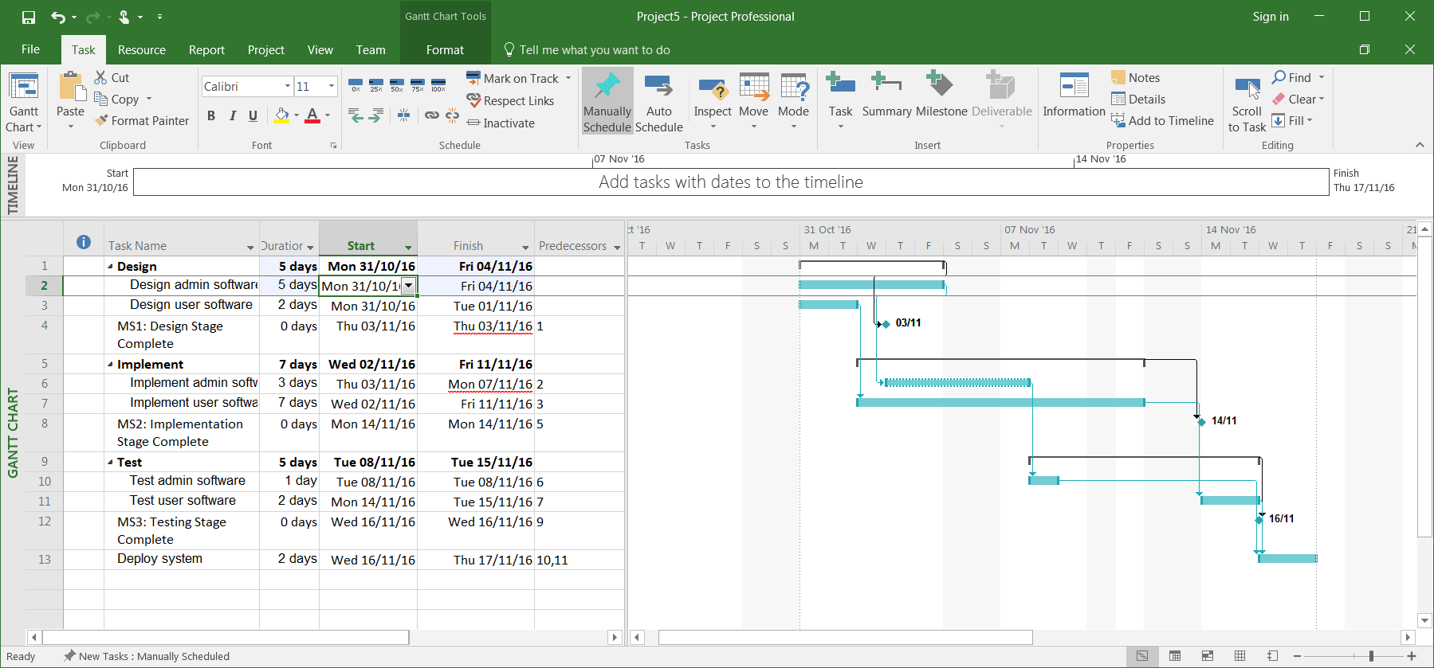

You might have spotted that this causes a problem. Task 2, which is a predecessor of Task 6, is now scheduled to finish after Task 6 begins. In other words, the dependency of Task 6 on Task 2 is no longer being respected. MS Project identifies this as a problem – notice that on the Gantt chart, the appearance of Task 6 has changed slightly – its outline is now a dashed line (not solid). However, in Manually Schedule mode, MS Project does not correct this problem.

At this point, one option would be to manually edit the start date of Task 6. This is ok for a small project, but in larger projects with many tasks and potentially many schedule changes, this might prove time consuming and error prone.

MS Project provides a more palatable solution in the form of its Auto Schedule mode, in which the whole project or individual tasks can be automatically scheduled/re-scheduled.

To change to Auto Schedule for an existing task, select the Task, switch to Task tab and from the Tasks group select Auto Schedule. Try this for Task 6. You should get:

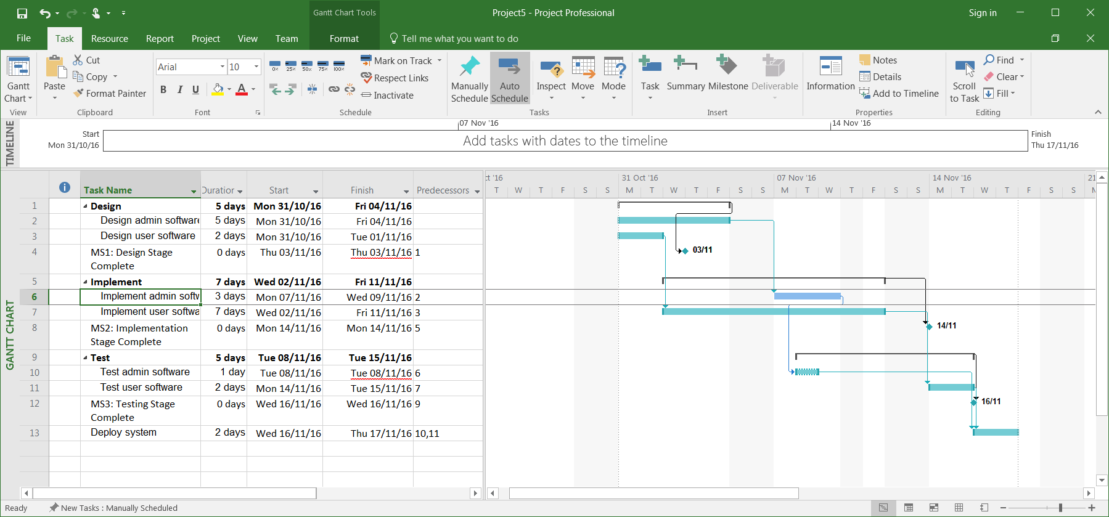

Notice that Task 6 has been re-scheduled to respect its dependency on Task 2. Its appearance has also changed – it is now coloured blue to indicate it is an automatically scheduled task.

Also, notice that the Auto Schedule option (Task tab, Tasks group) remains highlighted. This means that any new task added to the project will be automatically scheduled.

In general, it is probably best to automatically schedule all tasks (at least for the exercises undertaken on this module). Before proceeding, switch all the tasks to Auto Schedule:

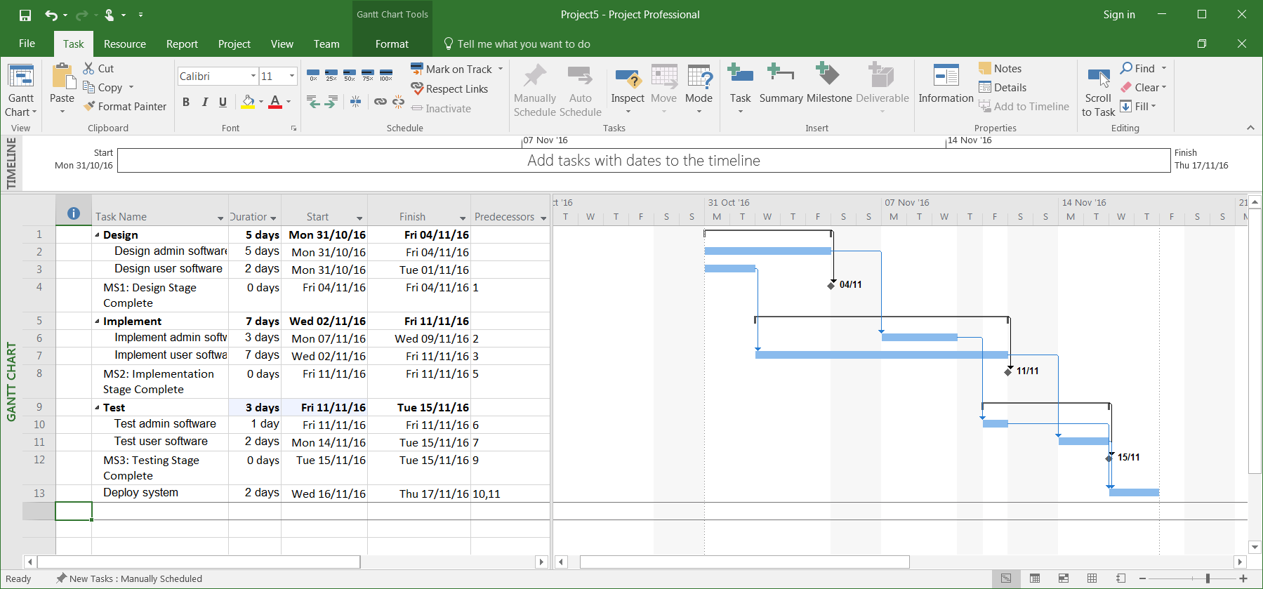

Save your project, you will need it again.

**3. Practice**

Open the “BuildRestaurant" project.

Switch all project tasks to Auto Schedule mode (MS Project seems to treat Summary Tasks differently to regular Tasks when in Manual mode, switching them all to Auto makes things more straightforward).

Now update it the project so that it includes the following dependencies:

|  |  |  |  |
| --- | --- | --- | --- |
| **Task Id** | **Task name** | **Duration** | **Predecessor** |
| 1 | Pre-build | 40 days |  |
| 7 | MS1: Pre-build complete | 0 days | 1 |
| 8 | Build | 75 days | 7 |
| 13 | MS2: Build complete | 0 days | 8 |
| 14 | Post-build | 10 days | 13 |
| 18 | MS3: Post-build complete | 0 days | 14 |
| 19 | Open rest | 0 weeks | 18 |

These dependencies have been set up to ensure there is no overlap between summary tasks – that is, no task belonging to a summary task can start until all tasks in previous summary task has been completed. It is sometimes (but not always) necessary to organise projects in this way.

You project should now look like:

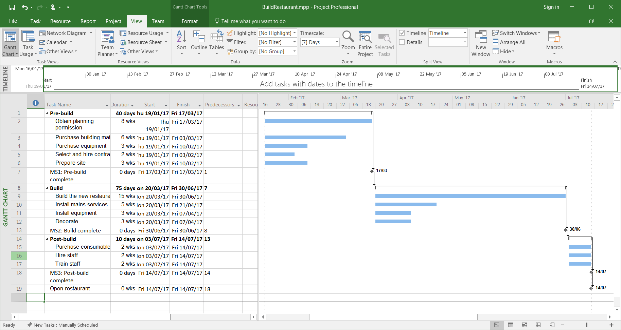

You should now add in the other dependencies:

|  |  |  |  |
| --- | --- | --- | --- |
| **Task Id** | **Task name** | **Duration** | **Predecessor** |
| 2 | Obtain planning permission | 8 weeks |  |
| 3 | Purchase building materials | 6 weeks | 2 |
| 4 | Purchase equipment | 3 weeks | 2 |
| 5 | Select and hire contractors | 2 weeks | 2 |
| 6 | Prepare site | 3 weeks | 3, 5 |
| 9 | Build the new restaurant | 15 weeks |  |
| 10 | Install mains services | 5 weeks | 9 |
| 11 | Install equipment | 3 weeks | 10 |
| 12 | Decorate | 3 weeks | 11 |
| 15 | Purchase consumables | 2 weeks |  |
| 16 | Hire staff | 2 weeks |  |
| 17 | Train staff | 2 weeks | 16 |

Notice that due to the way in which we have set up summary task and milestone dependencies, at the point you only need to concern yourself with dependencies that exist between tasks belonging to the same summary task.

Your project should now look something like:

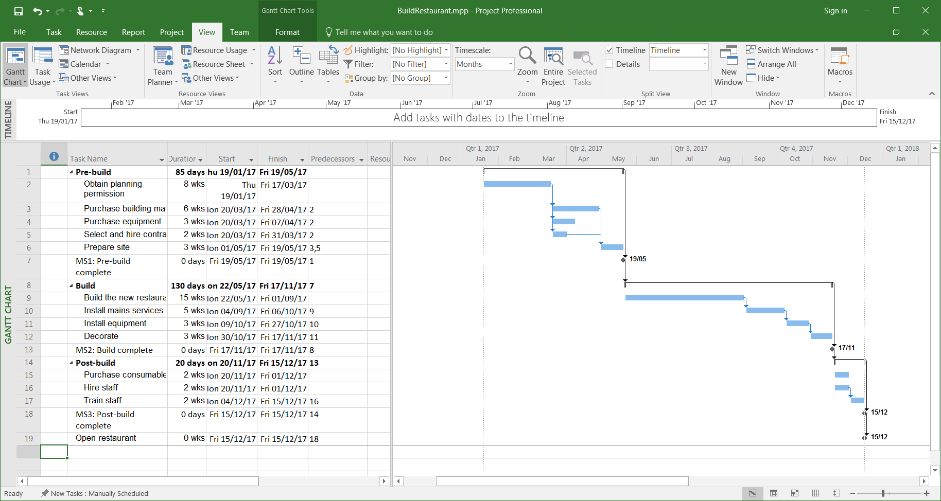

Change the durations of the following tasks:

|  |  |  |  |
| --- | --- | --- | --- |
| **Task Id** | **Task name** | **Duration** | **Predecessor** |
| 3 | Purchase building materials | 7 weeks | 2 |
| 12 | Decorate | 4 weeks | 11 |
| 16 | Hire staff | 3 weeks |  |

Make sure that dependent task start dates get updated to reflect these changes (in Auto Schedule mode this should happen automatically). The new project finish date should be 05/01/2018.

Save your project, you will need it again.